Semiconductor Characteristics Research Proposal

Chris Knotek and Akash Mullick

1. INTRODUCTION

Transition metal dichalcogenides (TMDCs) provide a promising alternative to silicon and germanium semiconductor applications as well as other common materials.1 TMDCs have the chemical formula MX2, where M is a transition element and X is chalcogen.1 Typically the bandgap of TMDCs is typically in the range of visible light, which makes them candidates for use in photovoltaic cells.1 Conversely TMDCs have potential to produce flexible and transparent LEDs, although the required doping makes fabrication difficult.1

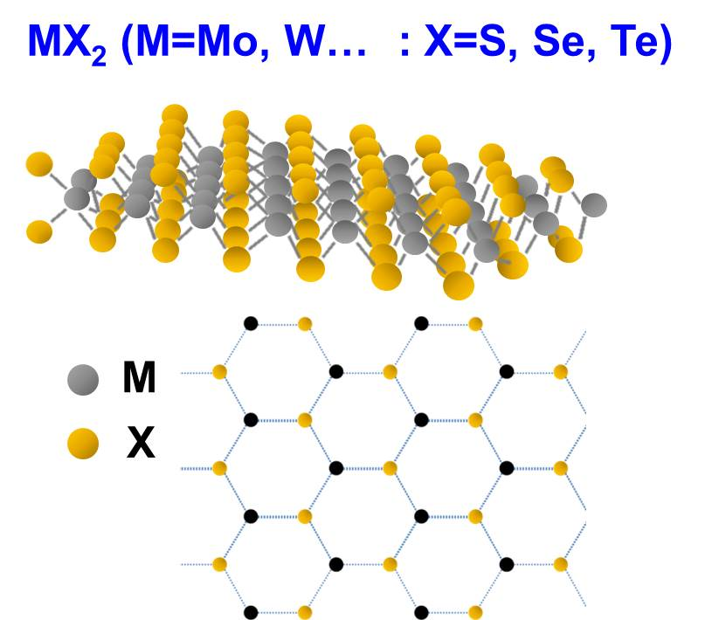

1. SUMMARY

Our previous work over the last two weeks has focused on analyzing the diffusion of electron hole pairs through \*the material\*. Our experiment was a photoluminescence test of a 2D sample of \*material\* with 1297 time measurements of a 41x41 pixel area over \*time\* seconds. We were given our first set of data to work with the first day we went into the lab. The data was generated by the photoluminescence test. We used Pylab to create and plot heatmaps of the intensity of light emitted at every portion of the material over time. We graphed a heatmap for every 10th timestamp in order to make the visualization more concise. We have used python with scipy and lmfit libraries to fit curves to the intensity of single points of the material over time after an incident with a visible light wavelength laser. When fit to a differential equation, the fit constants provide rates of spreading of the carriers through diffusion, radiative and nonradiative recombination, and thermal processes. Additionally we have graphed the general spread of the carrier pairs over time, based on the width of the bright area of the sample. The graph revealed that the width remained near zero for several time steps before continually increasing. We applied a filter to the data to reduce the noise, which made it easier to generate conclusions from the graph. Using the same set of data, we then plotted the intensity of the center point of the nanomaterial versus tim, and then fit the data using a double exponential curve. To see how the plot compared to that of pixels nearby, we plotted the intensity versus time of each pixel in the same row. At the end of the two weeks, we were given three more sets of data which we will be analyzing along with other work during the next two weeks.

1. PROPOSAL

Our goal during the following two weeks is to characterize how charges move around in two dimensional transition metal dichalcogenides. Our experiment will consist of temporal and spatial photoluminescence (PL) tests of tungsten disulfide (WS2) to determine how significantly the diffusion, recombination, and electron traps of the sample affect the spread of electron/hole pairs through the material. If possible, transient absorption microscopy tests will be used in conjunction to support our PL experiment. Our experiments will utilize photoluminescence microscopy in multiple ways. The simplest and first way we collected photoluminescence data was by directing a laser onto the center of the nanomaterial layer, and then recording the intensity of the emitted photon at a certain location for the entire lifetime of the process. The location from which the emission is measured is moved and a laser pulse is directed to the center again, and another emission is measured over the lifetime of the process. The pulse-measure process is repeated for a 41x41 area of the nano material. The amount of emission measured is proportional to the square of density of excited electrons in the material. Given the energy, time, and wavelength of the laser, the number of photons colliding with the material can be calculated, and under the assumption that every photon results in an excited electron, the initial density of excited electrons can be calculated. The initial density, *D0*, can be used to convert photoluminescence data to electron density data. Fitting a differential equation to the data provides insight into the effectiveness of radiative/non-radiative recombination, electron traps, and diffusion in the spread of electrons in the material. A lower rate of diffusion is desirable in semiconductors for photovoltaic cells, which require the separation of electron-hole pairs due to visible light to produce a voltage. Another way of generating data with photoluminescence microscopy is to measure the photon emission for the same location as the laser. The laser focus on the material for a significant amount of time (¼ of a second), and the emission during this time is measured. Mapping the peak wavelength intensity of an area of the material can show how uniform the supposedly single layer sheet is. Thinner materials have higher mobility, producing better results in applications such as PV cells. The

1. LITERATURE CITED
2. Jariwala, Deep, et al. “Emerging Device Applications for Semiconducting Two-Dimensional Transition Metal Dichalcogenides.” *ACS Nano*, vol. 8, no. 2, 2014, pp. 1102–1120., doi:10.1021/nn500064s.